SET 26: STUDENT PERFORMANCE ANALYSIS
Dataset: Student_Mini_Data.csv

Department | AIML
Course Code / Course Name | DSA0602 / Data Handling and Visualization
Experiment | Data Visualization using R and Tableau
Name | A Shiva Shankar Reddy
Register Number | 192425174
Date | 20 October 2026
Day | Tuesday

Student_ID | Gender | Study_Hours | Attendance | Math_Score | Science_Score | Exam_Date
S01 | Male | 2.0 | 78 | 62 | 65 | 2025-01-10
S02 | Female | 3.5 | 90 | 80 | 85 | 2025-01-10
S03 | Male | 1.5 | 70 | 55 | 58 | 2025-02-12
S04 | Female | 4.0 | 95 | 90 | 92 | 2025-02-12
S05 | Male | 2.8 | 85 | 72 | 74 | 2025-03-15
S06 | Female | 3.0 | 92 | 82 | 86 | 2025-03-15

PROGRAM 1: Histogram of Math_Score and Boxplot of Science_Score by Gender
Question: Import the dataset in R. Plot a histogram for Math_Score. Draw a boxplot of Science_Score by Gender. Add proper title and labels. Interpret the results.

# Import the dataset
students <- read.csv("Student_Mini_Data.csv") str(students)

# Show both plots side by side par(mfrow = c(1, 2))

# Histogram of Math_Score hist(students$Math_Score, breaks = seq(50, 90, by = 10), main = "Histogram of Math Scores", xlab = "Math Score", ylab = "Frequency",
col = "#4E79A7", border = "black")

# Boxplot of Science_Score by Gender
boxplot(Science_Score ~ Gender, data = students,
main = "Science Score by Gender", xlab = "Gender", ylab = "Science Score", col = c("#E15759", "#4E79A7"))
par(mfrow = c(1, 1))

Output 1: Histogram and Boxplot

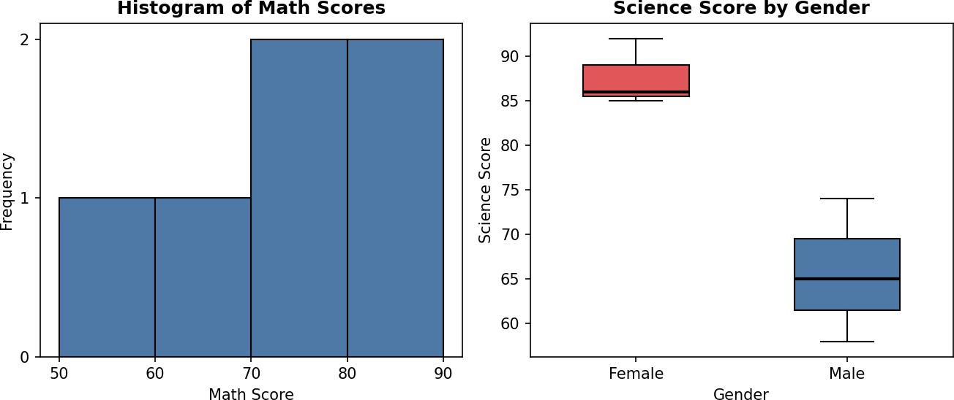
Observation: Math scores range from 55 to 90 with a mean of 73.5 and a median of 76. The histogram is spread fairly evenly, with the 70-90 range holding four of the six students and no extreme outliers. In the boxplot, the female group has a median Science score of 86 (range 8592), while the male group has a median of 65 (range 58-74). The two boxes do not overlap at all, so female students scored clearly higher in Science in this sample. Female scores are also more tightly clustered. With only six students, this is a descriptive comparison rather than a statistically tested one.

PROGRAM 2: Scatter Plot of Study_Hours vs Math_Score with Regression Line
Question: Create a scatter plot using R programming between Study_Hours and Math_Score. Use different colors for Gender. Add a regression line. Explain the relationship between study time and performance.

# Colours by gender
students$Colour <- ifelse(students$Gender == "Male", "#4E79A7", "#E15759")

# Scatter plot
plot(students$Study_Hours, students$Math_Score, main = "Study Hours vs Math Score", xlab = "Study Hours (per day)", ylab = "Math Score",
col = students$Colour, pch = 19, cex = 1.5)

# Regression line and legend
model <- lm(Math_Score ~ Study_Hours, data = students) abline(model, lwd = 2) legend("topleft", legend = c("Male", "Female", "Regression line"), col = c("#4E79A7", "#E15759", "black"),
pch = c(19, 19, NA), lty = c(NA, NA, 1), lwd = c(NA, NA, 2))

# Model results coef(model) cor(students$Study_Hours, students$Math_Score) summary(model)$r.squared

Output 2: Scatter Plot with Regression Line

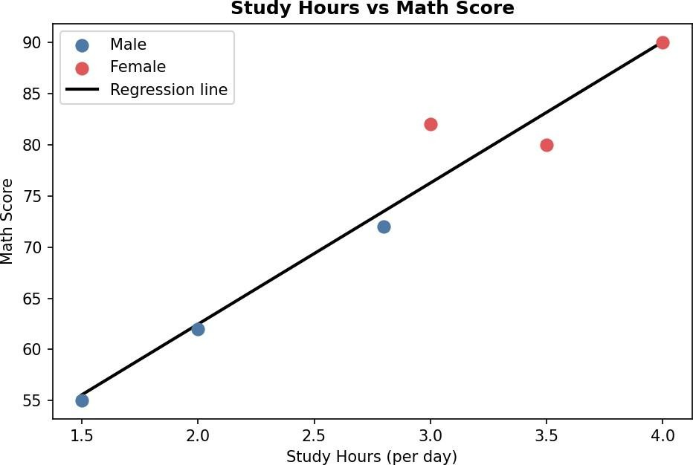

Console output

> coef(model)
(Intercept) Study_Hours
34.88605 13.79070
> cor(students$Study_Hours, students$Math_Score)
[1] 0.9731713
> summary(model)$r.squared
[1] 0.9470624

Observation: The points rise steadily from left to right, so study time and Math score have a strong positive linear relationship (r = 0.973, R-squared = 0.947). The fitted line is Math_Score = 34.89 + 13.79 x Study_Hours, meaning each extra hour of daily study is associated with about 14 more marks. The slope is statistically significant (p = 0.001). The female students sit in the upper right (more study, higher scores) and the male students in the lower left. This shows association, not proof of causation, and the sample is only six students.

PROGRAM 3: Monthly Average Math Score with Moving Average
Question: Using R, convert Exam_Date into Date format. Calculate monthly average Math scores. Plot a line chart for the trend. Apply moving average smoothing. Identify any increasing or decreasing pattern.

# Convert Exam_Date to Date students$Exam_Date <- as.Date(students$Exam_Date) students$Month <- format(students$Exam_Date, "%Y-%m")

# Monthly average Math score
monthly <- aggregate(Math_Score ~ Month, data = students, FUN = mean) monthly$Month_Date <- as.Date(paste0(monthly$Month, "-01"))

# 2-month moving average (uses the current and previous month) monthly$MovingAvg <- as.numeric(stats::filter(monthly$Math_Score, rep(1/2, 2), sides = 1))
print(monthly)

# Line chart
plot(monthly$Month_Date, monthly$Math_Score, type = "o", pch = 16, lwd = 2, col = "#4E79A7", main = "Monthly Average Math Score with Moving Average", xlab = "Month", ylab = "Average Math Score", ylim = c(68, 80), xaxt = "n")
axis.Date(1, at = monthly$Month_Date, format = "%b %Y") text(monthly$Month_Date, monthly$Math_Score, labels = monthly$Math_Score, pos = 3)

# Moving average line
lines(monthly$Month_Date, monthly$MovingAvg, type = "o", pch = 15, lwd = 2, lty = 2, col = "#E15759")
legend("topleft", legend = c("Monthly average", "2-month moving average"), col = c("#4E79A7", "#E15759"), lty = c(1, 2), pch = c(16, 15), lwd = 2)

Output 3: Monthly Trend Line Chart

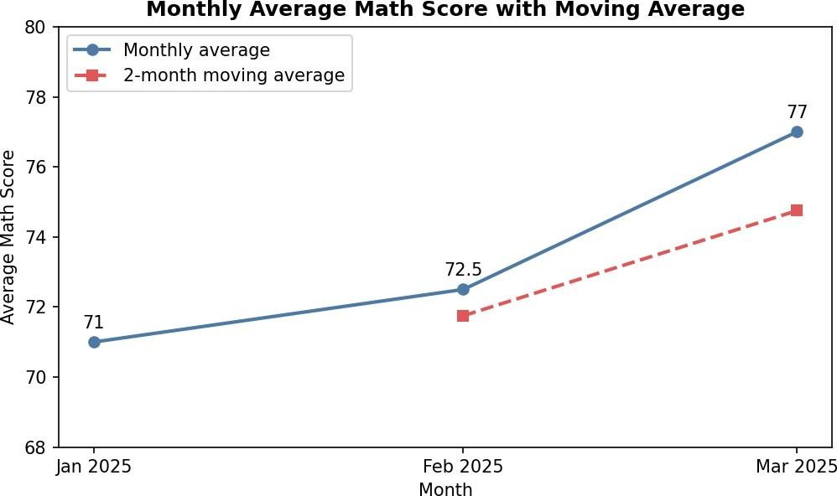

Console output

Month Math_Score Month_Date MovingAvg
- 2025-01 71.0 2025-01-01 NA
- 2025-02 72.5 2025-02-01 71.75
- 2025-03 77.0 2025-03-01 74.75

Observation: The monthly average Math score rises from 71.0 in January to 72.5 in February and 77.0 in March, an overall gain of 6 marks. The moving average also climbs, from 71.75 to 74.75, so the smoothed series confirms a consistent increasing pattern with no decline. The increase is larger from February to March (+4.5) than from January to February (+1.5). A 2month window was used because there are only three months of data.

PROGRAM 4: Interactive Student Performance Dashboard in Tableau
Question: Import Student_Mini_Data.csv into Tableau. Create a bar chart showing average Math scores by Gender. Create a line chart for score trends over time. Add a filter for Exam_Date. Design a simple interactive dashboard.

Tableau Steps
- Open Tableau, choose Connect > Text file and select Student_Mini_Data.csv.
- On the Data Source tab, check the field types: set Exam_Date to Date, Gender to String, and the score and hours fields to Number (decimal or whole).
- Create a worksheet named "Avg Math by Gender". Drag Gender to Columns and Math_Score to Rows, then change the aggregation to Average (right-click the pill > Measure > Average).
- In the Marks card choose Bar, drag Gender to Color, and turn on mark labels (Format > Labels). Title it "Average Math Score by Gender" and label the axes.
- Create a worksheet named "Score Trend". Drag Exam_Date to Columns (choose Month or
Exact Date as a continuous field) and Math_Score to Rows (Average). Choose Line in the Marks card.
- Drag Gender to Color so each gender has its own line, show mark labels, and title it "Math Score Trend by Exam Date". Optionally add a trend line from the Analytics pane.
- Add the Exam_Date filter: drag Exam_Date to Filters, choose Range of Dates, click OK, then right-click the filter and select Show Filter. Choose Apply to Worksheets > All Using This Data Source.
- Create a worksheet named "Student Table" with Student_ID on Rows and Measure Names / Measure Values showing Study_Hours, Attendance, Math_Score and Science_Score.
- Click New Dashboard, set the size to Automatic, and drag in the bar chart, line chart and table. Add the title "Student Performance Dashboard".
- Select the bar chart and click the Use as Filter icon so clicking a gender updates the line chart and table. Show the Exam_Date and Gender filters on the dashboard.
- Test the dashboard: click the Female bar, change the Exam_Date range, and check that the line chart and table update.

Output 4: Student Performance Dashboard (layout preview)

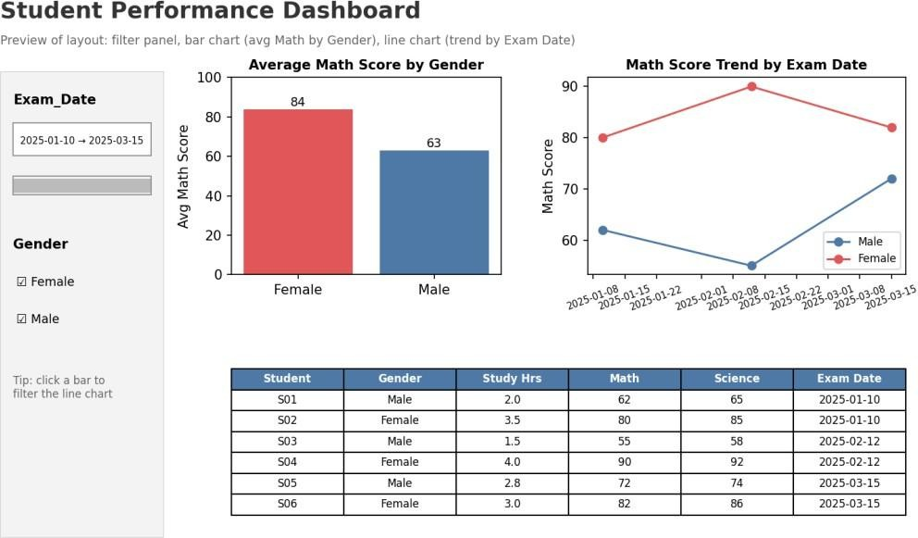

Observation: The dashboard combines the average Math score by Gender bar chart, the score trend line chart and a student table, controlled by the Exam_Date range filter and click-to-filter actions. Female students average 84 against 63 for male students, and the trend lines show both groups scoring higher by March than in January.

Procedure
- Import Student_Mini_Data.csv into R using read.csv().
- Plot the histogram of Math_Score with hist() and the boxplot of Science_Score by Gender with boxplot().
- Draw the scatter plot of Study_Hours against Math_Score with colours by Gender and add the regression line using lm() and abline().
- Convert Exam_Date with as.Date(), compute monthly averages with aggregate(), and apply a moving average using stats::filter().
- Plot the monthly trend and moving average as a line chart and identify the pattern.
- Import the dataset into Tableau and build the bar chart, line chart and table worksheets.
- Add the Exam_Date filter, combine the worksheets in a dashboard and enable Use as Filter.
- Test the dashboard interactivity.

Result
The Student_Mini_Data was successfully analysed in R and Tableau. Math scores are spread between 55 and 90, female students scored higher in Science, study hours are strongly and positively related to Math performance (r = 0.97), the monthly average Math score shows an increasing trend from 71.0 to 77.0, and an interactive Tableau dashboard was designed for exploring the results.

